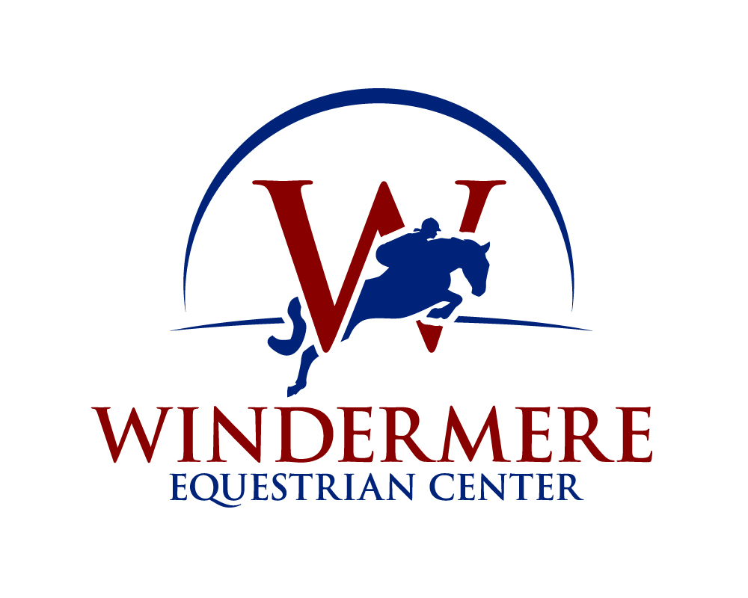

Volunteer Application
Spirit Horse at Windermere Equestrian Center

Volunteering at Spirit Horse at Windermere Equestrian Center can be a very rewarding experience. Safety is our number one concern for our animals and our volunteers.

To discuss your interest in volunteering, please contact our volunteer coordinator listed below.

The minimum age for volunteers is 14. Younger children may volunteer with adult supervision and participate in family volunteering.

Once you have submitted your application, it will be reviewed by the coordinator and you will be contacted. The coordinator will set up a time for you to attend the next Safety Training session held at the barn. Once you have completed and passed your safety training, the coordinator will schedule a time for your first volunteer session.

We look forward to working with you.

Volunteer Coordinator: Kim Smith
Ksmitty5252@yahoo.com

VOLUNTEER APPLICATION
Updated January, 2018

Thank you for your interest in our organization so that we can best utilize your experience and interests, please complete this application form as fully as possible.

- PERSONAL INFORMATION (Please print legibly)
Participant Name:
First M.I. Last
□ Female □ Male Participant’s DOB (mm/dd/yy):

Participant Cell#:

If under 18 years of age, print Parent/Guardian name:
May we send text messages on this number?
□ No □ Yes

Name:
First M.I. Last

Address: City/State: Zip:

Cell#: ( ) Work#: ( ) Home#: ( )_

Employer/Occupation:

Email: Providing my email address allows Spirit Horse WEC to send me program news, updates, information, and etc. This email shall remain the property of Spirit Horse and will not be sold or given to any third parties.

How did you first learn about Spirit Horse BTF?
□ Radio/TV □ Newspaper □ Internet □ School/College □ Referral
Please specify referring Organization/Individual/Other:

- TIME COMMITMENT

What is your availability and amount of time you are interested in volunteering?
- Weekly □ Monthly □ Occasionally
Our typical hours of operation are Sunday through Saturday starting around 8:00‐‐‐9:00 AM to 6:00‐‐‐7:00 PM. Please indicate below what time frames you are available.

Monday Tuesday Wednesday Thursday

Friday Saturday Sunday
INTERESTS

Why do you want to volunteer with Spirit Horse?

Please list any special skills that you could offer (i.e., sign language, computer, carpentry, Spanish)

Please describe your general background (i.e., education, workexperience)

- SPECIAL OPPORTUNITIES

Please check all volunteer areas you would be interested in.
- Instructor □ Side‐‐‐walker
- Horse care: Feeding, leading to and from pastures, grooming, etc.
- Facility: □ Cleaning stalls, pastures & paddocks □ Carpentry
□ General maintenance & repairs
- Special Events & Fundraisers: □ Planning committees □ Assist on day of event
- Office

- RELATED EXPERIENCE AND SKILLS
Have you ever been affiliated with Spirit Horse as a volunteer or rider? □No □ Yes If yes, when?
Have you had previous experience working with horses? □ No □ Yes
If yes, please describe:

Have you had previous experience working with youths who are at‐‐‐risk or have suffered victimization or abuse?
□No □Yes If Yes, please describe including specific skills/degrees:

Are you Certified In? □First Aid □CPR Certificate expires on:

Do you have a special skill, technical/professional that might be beneficial to Spirit Horse? If so, please check all that apply:
- Marketing □ Construction □ Fundraising □ Photography
- Grant Writing □ Graphic Design □ Event Planning
- Other:

- SCHOOL/COMMUNITY SERVICE INFORMATION (Only complete if applies to you)

If you’re volunteering to complete school curriculum service hours, how many hours do you need to fulfill your requirement?
What school do you attend?
What academic year you are in currently:
□ Freshman □ Sophomore □ Junior □ Senior

- BACKGROUND

Have you ever been convicted, pleaded no contest or pleaded guilty to a felony or misdemeanor?
□ No □ Yes If yes, please
elaborate:
If you are volunteering to complete your court mandated community service, how many hours do you need to fulfill your requirement? By when?
Who’s the referring court? Judge?
Name of Probation Officer? Phone#: ( )

Volunteer Release of Liability
I, (Participant’s Name) would like to participate in the Spirit Horse at Windermere Equestrian Center volunteer program. I acknowledge the risks and potential risks of horseback riding and related activities. I however, feel the possible benefits to myself/my son/my daughter/my ward are greater than the risk assumed. I hereby, intending to be legally bound, for myself, my heirs, my assigns, executors or administrators, waive and release forever all claims for damages against Andrew Anderson, Spirit Horse at Windermere Equestrian Center, its Board of Directors, Guarantors, Instructors, Aides, Volunteers and/or Employees for any and all injuries and/or losses I or my son/my daughter/my ward may sustain while participating in Spirit Horse programs. WARNING ‐‐‐ Under Florida law (FL ST 773.01 – 773.06) an equine professional is not liable for an injury to or the death of a participant in equine activities resulting from the
inherent risks of equine activities.

Participant’s Signature:
If under 18 years of age, parent/guardian signature required below.
Signature:
Date: Date:

Photo and Video Consent
I, _________________________________________ consent or do not consent to authorize the use and reproduction by Spirit Horse Therapeutic Center of any and all photographs, video/audio materials taken of me for the purpose of on‐‐‐going studies, educational activities, exhibitions, promotional materials, marketing or for any other use for the benefit of the program.

Participant’s Signature:
If under 18 years of age, parent/guardian signature required below.
Signature:

Applicant Information

I hereby authorize SpiritHorse to request and receive any and all background information about or concerning me, including but not limited to my Criminal History, 15 U.S.C 1681, Driving Record, Employment History, Military Background, Civil Listings, Educational Background, Professional License, Corporation, Partnership, Law Enforcement Agency, and other entities including my Present and Past Employers.

The criminal history, as received from the reporting agencies, may include arrest and conviction data as well as plea bargains, deferred adjudications and delinquent conduct committed as a juvenile. I understand this information will be used, in part, to determine my eligibility for a volunteer position with SpiritHorse. I also understand as long as I remain a volunteer here, the criminal history check may be repeated at any time. I understand I will have an opportunity to review the criminal history as received by client/agency and a procedure is available for clarification, if I dispute the record as received.

I further release and discharge SpiritHorse and all their Subsidiaries, Affiliates, Officers, Employees, Contract Personnel, from any and all claims and liability arising out of any request for information or records pursuant to this authorization, and understand that it may contain information about my character, general reputation, personal characteristics, and mode of living, whichever are applicable.

I acknowledge I have voluntarily provided information for volunteer purposes, and I have carefully read and understand this authorization.

Participant’s Signature: Date:

If under 18 years of age, parent/guardian signature required below.

Signature: Date:

Mail this application to: Spirit Horse at Windermere Equestrian Center
Attn: Volunteer Coordinator PO Box 784852
Winter Garden, FL 34778

Email this application to:

Ksmitty5252@yahoo.com

LIABILITY WAIVER
Updated JAN, 2018

Participant’s Name:

I/We understand that horseback riding and related activities are very dangerous and involve the risk of serious injury and/or death, and/or property damage, including injury and/or death to horses, spectators and others. Accordingly, I/We agree that any activity engaged in by me on the premises of Spirit Horse at WEC, WEC or related to horses or horseback riding, if on the premises, is done at my own risk. Accordingly, I/We release and agree to hold harmless Spirit Horse at Windermere Equestrian Center and Windermere Equestrian Center along with their owners and employees, and any and all persons or entities who are guarantors or indemnities of the above, all agents, employees, promoters, sponsors, other horse riders, horse owners, advertisers, sales persons, photographers, volunteers, (hereinafter called Releasees) from all liability for negligence or otherwise.
I/We assume full responsibilities for the risk of bodily injury, illness, death of myself/my son/my daughter/my ward and/or my/their horse(s) and any property damage due to the negligence of Releasees or otherwise while on the premises of Spirit Horse at Windermere Equestrian Center or Windermere Equestrian Center along with their owners and employees or heavily engaged in horseback riding related activities, and/or while training, riding, competing, officiating, observing, volunteering, teaching, boarding, working for, or for any purpose relating to horseback riding, eventing, or participating as rider or spectator in such activities.
I/We agree not to sue any Releasees, and I/We release and agree to indemnity for the Releasees from and for all liability for the undersigned, his/her person, representatives, assignees, heirs, and demands therefore on account of injury to his/her person or property, or death of the undersigned whether caused by the negligence of the Releasees or otherwise.
I/We agree that this release, waiver, and indemnity agreement is intended to be as broad and inclusive as is permitted by the law of this state where these activities are conducted, and if any part hereof is held invalid, it is agreed that the balance shall continue of full force and effect.
I/We have read and voluntarily signed the release and waiver of liability and indemnity agreement and further agree that no oral representations, statements, or inducements apart from the foregoing written agreements have been made nor shall be made except by a written and signed addendum.

Warning, under Florida law, an equine activity sponsor or equine professional is not liable for an injury to or the death of, a participant in equine activities resulting from the inherent risks of equine activities.
I have read this entire release and agree to its contents.

Participant’s Signature: Date:

If under 18 years of age, parent/guardian signature required below.

Signature: Date:

AUTHORIZATION FOR EMERGENCY MEDICAL TREATMENT
Specific information is requested in the event the participant is unable to present this information on their ownbehalf.

Participant’s Name: DOB (mm/dd/yy):

In the event of an emergency, contact:
Name: Relation: Phone: Name: Relation: Phone: Name: Relation: Phone:
In the event emergency medical aid treatment is required due to illness or injury during the process of receiving services, or while being on the property of the agency, I authorize Spirit Horse at Windermere Equestrian Center or Windermere Equestrian Center to:
- Secure and retain medical treatment and transportation if needed.
- Release volunteer records upon request to the authorized individual or agency involved in the medical emergency treatment.

Participant’s Signature:

If under 18 years of age, parent/guardian signature required below.
Signature:
Date:

Date:

CONSENT PLAN

I DO give authorization that may include x‐‐‐ray, surgery, hospitalization, medication, and any treatment procedure deemed “life saving” by the physician. This provision will only be invoked if the emergency contact person(s) above is unable to be reached.
Physician’s Name: Physician’s Number: Preferred Medical Facility: Allergies to medications: Current medications:

Participant’s Signature:

If under 18 years of age, parent/guardian signature required below.
Signature:
Date: Date:

NON‐‐‐CONSENT PLAN

I DO NOT give my consent for emergency medical treatment aid in the case of illness or injury during the process of receiving services or while being on the property of the agency. In the event emergency treatment aid is required, I wish the following procedures to take place:

Participant’s Signature:

If under 18 years of age, parent/guardian signature required below.
Signature:
Date: Date:

